Software Requirements Specification

Speed Bump WEB

**ــــــــــــــــــــــــــــــــــــــــــــــــــــــــــــــــــــــــــــــــــــــــــــــــــــــــــــــــــــــــــــــــــــــــــــــــــــــــــــــــــــــــــــــــــــــــــــــــــــــــــــــــــــــــــــــــــــــــــــ**

**Table of Contents**

Document Status: 1

Document History: 2

Reference Document: 2

Project Description: 3

Definition: 3

Features: 3

Key elements 3

Software context: 3

SRS Requirements: 3

## Document Status:

|  |  |  |
| --- | --- | --- |
| **Name** | PO_SB_SRS_WEB | |
| **Version** | V1.0 | |
| **Status** | proposed | |
| **Author** | Ahmed Mohamed | |
| **Date** | [1-14-2022] | |
| **Team Approval** |  |  |
| **Mentor Approval** |  |  |
| **Final Approval** |  |  |

## Document History:

|  |  |  |  |
| --- | --- | --- | --- |
| **Version** | **Author** | **Date** | **Change** |
| 1.0 | Ahmed Mohamed | [1-14-2022] | Initial Creation |

## Reference Document:

|  |  |  |  |
| --- | --- | --- | --- |
| **Ref.number** | **Doc.Name** | **Version** | **Status** |
| 1 | PO_SB_CRS_WEB | V1.3 | proposed |

## Project Description:

### Definition:

The website for customers to purchase the speed bump detector device, and dashboard for the admin users to control the web site.

### Features:

* E-commerce for a customer to buy the device.
* Dashboard for an admin to control the website.

### Key elements

* User shall have an account.
* The E-commerce website shall show details about the product.
* Customer shall be able to place and track the order.
* Customer shall be able to send feedback.
* The website shall vary according to the user's role.
* On dashboard each admin user shall have an accou–nt.
* Dashboard shall contain page to display all users.
* Dashboard shall contain page to show keep track of stock.
* Dashboard shall contain page to show users’ feedback.

## Software context:

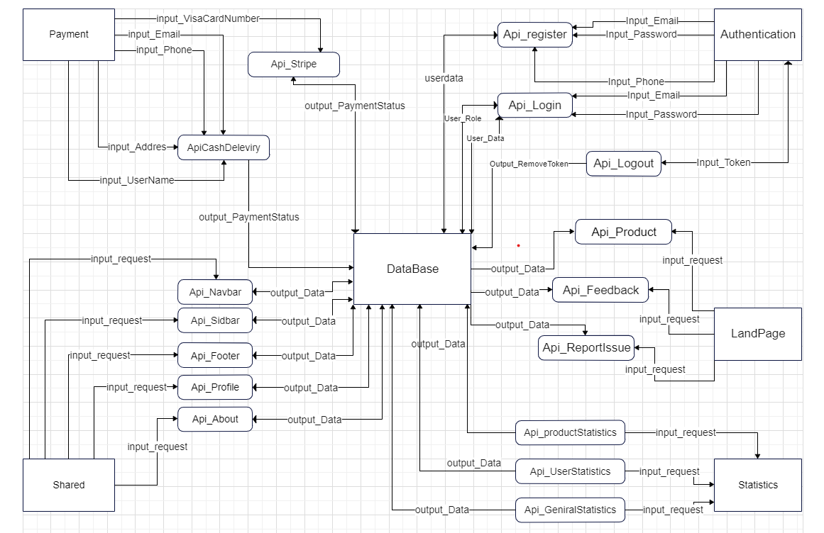

## SRS Requirements:

|  |  |  |  |
| --- | --- | --- | --- |
| **Req_ID** | PO_SB_SRS_**001**-V1.0 | **Covers** | PO_SB_CRS_**001**-V1.0 |
| **Description** | User shall register with name, email and password. | | |
| **Inputs** | Name ,Email and Password | **Outputs** | Add in user table in database |

|  |  |  |  |
| --- | --- | --- | --- |
| **Req_ID** | PO_SB_SRS_**002**-V1.0 | **Covers** | PO_SB_CRS_**002**-V1.0 |
| **Description** | User shall login with existing email and password. | | |
| **Inputs** | Email and password | **Outputs** | Redirect to website(landing Page) |

|  |  |  |  |
| --- | --- | --- | --- |
| **Req_ID** | PO_SB_SRS_**003**-V1.0 | **Covers** | PO_SB_CRS_**001**-V1.0 |
| **Description** | Credentials shall validate entered email and password. | | |
| **Inputs** | Email and Password | **Outputs** | Allow or Not |

|  |  |  |  |
| --- | --- | --- | --- |
| **Req_ID** | PO_SB_SRS_**004**-V1.0 | **Covers** | PO_SB_CRS_**001**-V1.0 |
| **Description** | Checking for email and password exist and each email matching his password. | | |
| **Inputs** | Email and Password | **Outputs** | Redirect to website or to login page |

|  |  |  |  |
| --- | --- | --- | --- |
| **Req_ID** | PO_SB_SRS_**005**-V1.0 | **Covers** | PO_SB_CRS_**002**-V1.0 |
| **Description** | User shall reset password using email | | |
| **Inputs** | Email | **Outputs** | New Password |

|  |  |  |  |
| --- | --- | --- | --- |
| **Req_ID** | PO_SB_SRS_**006**-V1.0 | **Covers** | PO_SB_CRS_**003**-V1.0 |
| **Description** | User/admin can login through Facebook account when he pressed login with Facebook button . | | |
| **Inputs** | Facebook Api | **Outputs** | Redirect to website(landing Page) |

|  |  |  |  |
| --- | --- | --- | --- |
| **Req_ID** | PO_SB_SRS_**007**-V1.0 | **Covers** | PO_SB_CRS_**004**-V1.0 |
| **Description** | User can login through google account when he pressed login with google button . | | |
| **Inputs** | Google email | **Outputs** | Redirect to website(landing Page) |

|  |  |  |  |
| --- | --- | --- | --- |
| **Req_ID** | PO_SB_SRS_**008**-V1.0 | **Covers** | PO_SB_CRS_**005**-V1.0 |
| **Description** | Landing Page shall show feature about product. | | |
| **Inputs** |  | **Outputs** | feature about product |

|  |  |  |  |
| --- | --- | --- | --- |
| **Req_ID** | PO_SB_SRS_**009**-V1.0 | **Covers** | PO_SB_CRS_**005**-V1.0 |
| **Description** | Landing Page shall show users reviews about product | | |
| **Inputs** |  | **Outputs** | reviews about product |

|  |  |  |  |
| --- | --- | --- | --- |
| **Req_ID** | PO_SB_SRS_**010**-V1.0 | **Covers** | PO_SB_CRS_**005**-V1.0 |
| **Description** | Landing Page shall show information about product | | | Landing Page shall show information about product |
| **Inputs** |  | **Outputs** | information about product |

|  |  |  |  |
| --- | --- | --- | --- |
| **Req_ID** | PO_SB_SRS_**011**-V1.0 | **Covers** | PO_SB_CRS_**006**-V1.0 |
| **Description** | User shall pay through the dashboard. | | |
| **Inputs** | Payment type | **Outputs** | data of users |

|  |  |  |  |
| --- | --- | --- | --- |
| **Req_ID** | PO_SB_SRS_**012**-V1.0 | **Covers** | PO_SB_CRS_**007**-V1.0 |
| **Description** | User shall filling in the details of the purchase (payment method, address, phone, email, name, city, postal code ,country, shipping price) | | |
| **Inputs** | Payment type | **Outputs** | data of users |

|  |  |  |  |
| --- | --- | --- | --- |
| **Req_ID** | PO_SB_SRS_**013**-V1.0 | **Covers** | PO_SB_CRS_**008**-V1.0 |
| **Description** | User can track their order, like (out for delivery , delivered , not configured) | | |
| **Inputs** | User info. | **Outputs** | payment is complete or not |

|  |  |  |  |
| --- | --- | --- | --- |
| **Req_ID** | PO_SB_SRS_**014**-V1.0 | **Covers** | PO_SB_CRS_**008**-V1.0 |
| **Description** | User shall know the payment process of product is complete or not | | |
| **Inputs** | User info. | **Outputs** | payment is complete or not |

|  |  |  |  |
| --- | --- | --- | --- |
| **Req_ID** | PO_SB_SRS_**014**-V1.0 | **Covers** | PO_SB_CRS_**009**-V1.0 |
| **Description** | User shall contact us through Landing Page. | | |
| **Inputs** | email | **Outputs** | Contact with him |

|  |  |  |  |
| --- | --- | --- | --- |
| **Req_ID** | PO_SB_SRS_**015**-V1.0 | **Covers** | PO_SB_CRS_**009**-V1.0 |
| **Description** | Users can send feedback | | |
| **Inputs** | Name ,email, Message | **Outputs** | Show his message |

|  |  |  |  |
| --- | --- | --- | --- |
| **Req_ID** | PO_SB_SRS_**016**-V1.0 | **Covers** | PO_SB_CRS_**009**-V1.0 |
| **Description** | Users can send report issues | | |
| **Inputs** | Name ,email, problem | **Outputs** | Try to solve his problem |

|  |  |  |  |
| --- | --- | --- | --- |
| **Req_ID** | PO_SB_SRS_**017**-V1.0 | **Covers** | PO_SB_CRS_**010**-V1.0 |
| **Description** | Role shall set by Website owner to user / admin | | |
| **Inputs** | role | **Outputs** | Redirect to landing page for user , dashboard for admin. |

|  |  |  |  |
| --- | --- | --- | --- |
| **Req_ID** | PO_SB_SRS_**018**-V1.0 | **Covers** | PO_SB_CRS_**010**-V1.0 |
| **Description** | Default each account register his role is user and super admin shall edit his role to admin. | | |
| **Inputs** | Email | **Outputs** | Redirect to landing page for user , dashboard for admin. |

|  |  |  |  |
| --- | --- | --- | --- |
| **Req_ID** | PO_SB_SRS_**019**-V1.0 | **Covers** | PO_SB_CRS_**011**-V1.0 |
| **Description** | Dashboard owner shall manage dashboard and control it. | | |
| **Inputs** | Super Admin | **Outputs** | manage dashboard |

|  |  |  |  |
| --- | --- | --- | --- |
| **Req_ID** | PO_SB_SRS_**020**-V1.0 | **Covers** | PO_SB_CRS_**012**-V1.0 |
| **Description** | Dashboard admin shall insert information about new devices | | |
| **Inputs** | Code, device_id, device_bluetooth, price | **Outputs** | insert information about new devices. |

|  |  |  |  |
| --- | --- | --- | --- |
| **Req_ID** | PO_SB_SRS_**021**-V1.0 | **Covers** | PO_SB_CRS_**014**-V1.0 |
| **Description** | Dashboard admin shall see summary about number of users. | | |
| **Inputs** |  | **Outputs** | number of users. |

|  |  |  |  |
| --- | --- | --- | --- |
| **Req_ID** | PO_SB_SRS_**022**-V1.0 | **Covers** | PO_SB_CRS_**015**-V1.0 |
| **Description** | Dashboard admin shall see summary about number of products was sold. | | |
| **Inputs** |  | **Outputs** | summary about number of products was sold |

|  |  |  |  |
| --- | --- | --- | --- |
| **Req_ID** | PO_SB_SRS_**023**-V1.0 | **Covers** | PO_SB_CRS_**01**-V1.0 |
| **Description** | Dashboard Admin shall handle track the order | | |
| **Inputs** | SB_dvice_id | **Outputs** | paid or not |

|  |  |  |  |
| --- | --- | --- | --- |
| **Req_ID** | PO_SB_SRS_**024**-V1.0 | **Covers** | PO_SB_CRS_**016**-V1.0 |
| **Description** | Dashboard admin shall see summary about number of products are available. | | |
| **Inputs** |  | **Outputs** | summary about number of products are available |

|  |  |  |  |
| --- | --- | --- | --- |
| **Req_ID** | PO_SB_SRS_**025**-V1.0 | **Covers** | PO_SB_CRS_**017**-V1.0 |
| **Description** | Dashboard admin shall see summary about users’ feedback | | |
| **Inputs** |  | **Outputs** | Show his message |